Engine Failure After Maintenance - B-Nuts
Abstract: Lasting 10 to 15 minutes, this presentation acquaints the audience with the hazards associated with loose B-Nuts
Format: Information Briefing - PowerPoint presentation
Required Personnel – FAASTeam Program Manager or designated FAASTeam Rep (s)
Optional Personnel – CFIs and Maintainers who can speak to the maintenance of general aviation aircraft.
AFS 850 Support:
In addition to this guidance document, a PowerPoint presentation that supports the program is provided. FPMs and presenters are encouraged to customize this presentation to reflect each individual program.

Appendix I – Equipment and Staging
Equipment:
- Projection Screen & Video Projector suitable for expected audience
  - Remote computer/projector control available at lectern or presenter location
    - In lieu of remote – detail a Rep to computer/projector control.
- Presentation Computer
  - Note: It is strongly suggested that the entire program reside on this computer.
- Back up Projector/Computer/Media as available.
- PA system suitable for expected audience
  - Microphones for Moderator and Panel
    - Optional Microphone (s) for audience
- Lectern (optional)
Staging:
- Arrange the projection screen for maximum visibility from the audience.
- Equip with PA microphones
- Place the lectern to one side of the screen. Presenters and moderator will use this.

Slides | Script
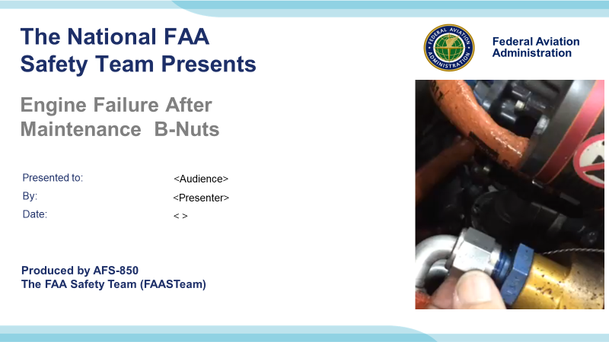 | Slide 1  2020/10-30-212(I)PP Original Author: Ken Kelley 10/30/2020; POC Guy Minor, AFS-850 Airworthiness Lead, Office (707) 704-3530 revised by Original 10/30/2020  Slide 1 is the title slide for Engine Failure After Maintenance - B-Nuts  - Script - We have included a script of suggested dialog with most slides. The script will always appear in a non-italic font. Presenters may read the script or modify it to suit their own presentation style. See template slides 5 and 6 for examples of slides with a script.  - Presentation Instructions - (stage direction and presentation suggestions) will be preceded by a Bold header: the instructions themselves will be in Italic fonts. See slides 2, 3, and 4 for examples of slides with Presentation Instructions only.  - Program control instructions - will be in bold fonts and look like this: (Click) for building information within a slide; or this: (Next Slide) for slide advance.  - Background information - Some slides may contain background information that supports the concepts presented in the program.  Background information will always appear last and will be preceded by a bold Background: identification.  The production team hope you and your audience will enjoy the show. Break a leg!  (Next Slide)
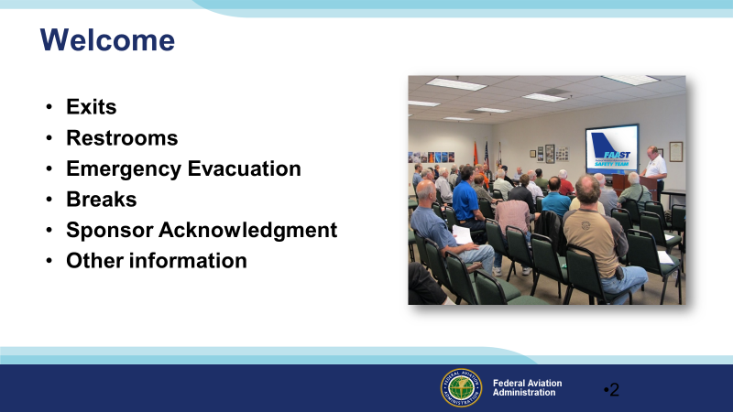 | Slide 2  Presentation Instruction: Here’s where you can discuss venue logistics, acknowledge sponsors, and deliver other information you want your audience to know in the beginning. You can add slides after this one to fit your situation.  (Next Slide)
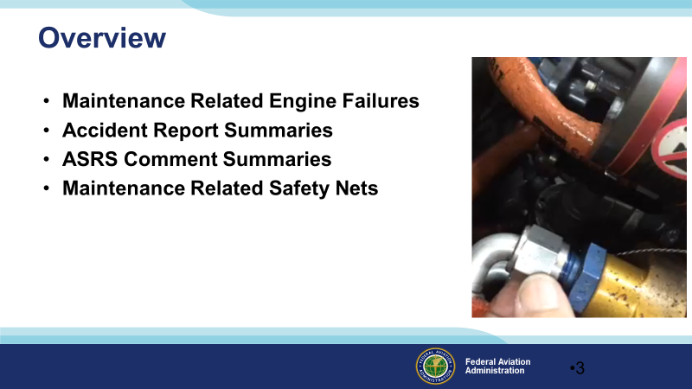 | Slide 3  In this presentation, we will explain why we are talking about B-Nuts  -Loose B-Nuts cause crashes  Show you some accident reports to get you in the mood  -In the mood to remember the safety nets  We’ll look at some NASA Aviation Safety Reporting System reports  -We get to learn easy lessons from those who found out the hard way.  Finally, we’ll cover some maintenance safety nets that might make forgetting to torque a B-Nut less likely.  Presentation Instruction: If you are discussing additional items, add them to this list  (Next Slide)
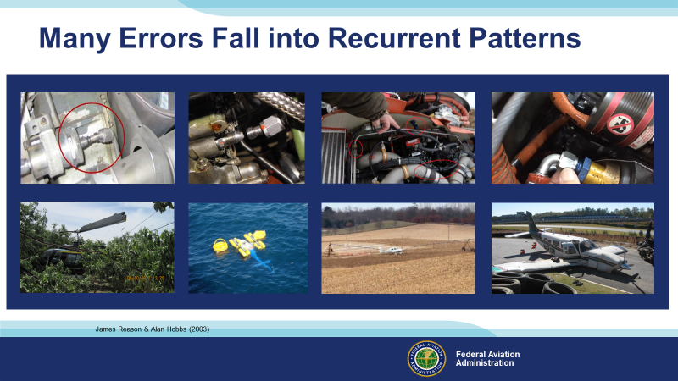 | Slide 4  Generally, if a loose B-Nut causes an accident, it was loose due to a mistake by the person who installed it. Loose B-Nuts seem to be one of the errors that fall into recurrent patterns. The good news is that we may understand the influences that cause the pattern and defend against them.  Background:  Many Errors Fall into Recurrent Patterns  Maintenance errors arise from either a unique combination of circumstances or from work situations that recur many times. The former are random errors—in the sense that their occurrence is very hard to foresee—while the latter are systematic or recurrent errors. More than half of the human factors incidents in maintenance have occurred before, often many times. We also observed that certain aspects of maintenance, particularly reassembly or reinstallation, commonly give rise to particular kinds of errors, notably omissions—leaving out essential steps in a sequence or failing to remove unwanted objects on completion. Another frequent group of errors involves miscommunication or lack of communication both within and between maintenance teams or shifts. Targeting these recurrent error types is the most effective way of deploying limited Error Management resources. James Reason and Alan Hobbs 2003  (Next Slide)
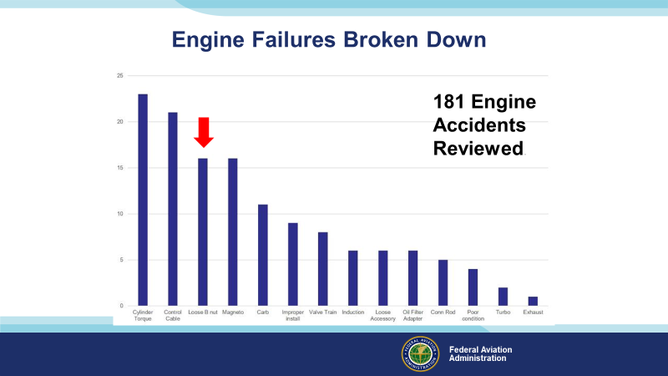 | Slide 5  Accidents caused by loose B-Nuts are surprisingly common. Loose B-Nuts follow cylinder torque and engine control cables as the third largest cause of maintenance error engine failures.  Background:  The information on the slide is from the FATDAT. To set the FATDAT to display maintenance-related engine failure, first enter “maintenance” in causal factors>select “aircraft” in level 1 category>select “aircraft power plant” in level2 subcategory>select “incorrect service/maintenance” in level 5 modifier.  (Next Slide)
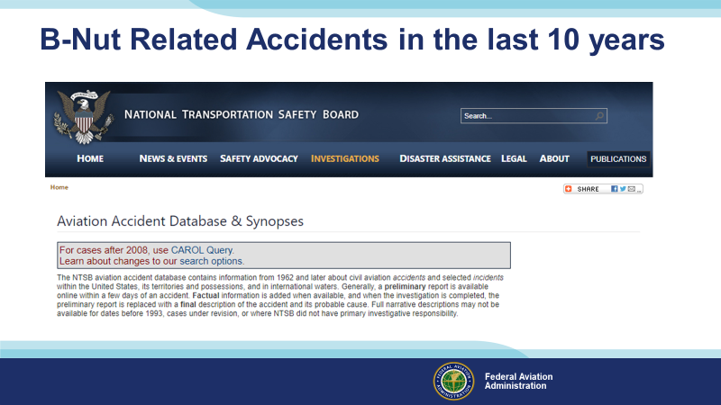 | Slide 6  Loose B-Nuts are one of these errors that seem to catch even the best maintainers. The NTSB Database shows 20 Accidents in the last ten years related to loose B-Nuts. These accidents were due to engine failure after maintenance with a causal factor listed as loose b-nuts.  Let’s have a look at some of these accidents. Just to get in the mood to listen to some reasons, these accidents may happen.  Background:  CEN17LA328, CEN10LA036, CEN12LA253, WPR11LA362, ERA11FA458, WPR14LA118, CEN16LA363, GAA19CA074, ERA15LA294, WPR15TA027, ERA10LA100, WPR13LA085, WPR10LA165, ANC18LA006, WPR14LA323, CEN11LA370, CEN16LA082, WPR15LA229, CEN12LA512, WPR12CA236  (Next Slide)
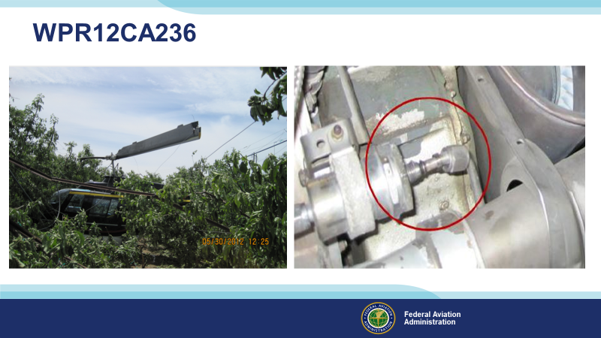 | Slide 7  On 05/30/2012, a Bell 206 was flying low over an apple orchard during an aerial application flight. The engine began to lose power, so the pilot started a hovering autorotation. An apple orchard is not a very good place to land. The pilot survived, but the helicopter not so much. The problem is in the red circle. The “B” nut that connected the tube to the PC air filter was present on the tube but not threaded onto the PC air filter boss. It was loose and vibrated free.  Background:  NTSB # WPR12CA236 Bell 206B  During an aerial application flight, the single-engine helicopter flew low over an apple orchard when the engine began to lose power. The pilot decreased his airspeed toward zero and performed a hovering autorotation into the orchard. During the landing, the rotor blades impacted the trees, and the tail boom separated from the main fuselage. An examination of the engine revealed that the compressor discharge pressure (PC) air tube, which connected the PC air filter to the power turbine governor was disconnected. The “B” nut that connected the tube to the PC air filter was present on the tube but not threaded onto the PC air filter boss. The threads on both the PC air filter boss and the “B” nut did not exhibit any damage or abnormalities. Review of the maintenance records showed that, about 6 hours before the accident, the turbine assembly and bleed valve had been replaced. Removal and reinstallation of the PC air tube was conducted as part of the documented maintenance. It is likely that maintenance personnel did not properly torque the “B” nut when reinstalling the tube and the loose “B” nut backed off in-flight. According to the engine manufacturer’s technical representative, disconnection of the PC air tube during engine operation would result in a loss of engine power.  (Next Slide)
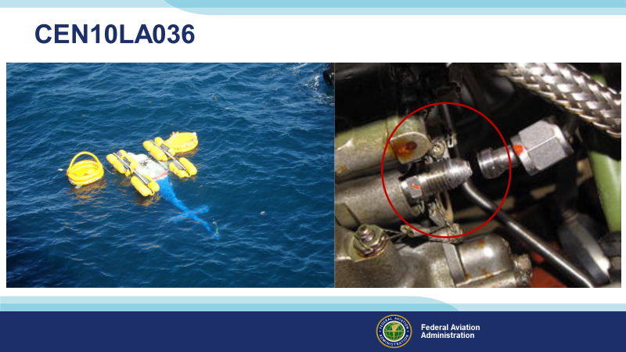 | Slide 8  11/01/2009, a Bell 206 lifted off from an offshore oil platform when the engine lost power, another very inconvenient time and place to have an engine quit. Again it was a loose B-Nut on the PC line.  Background:  NTSB# CEN10LA036 Bell 206  The helicopter had landed on an offshore oil platform and was refueled. It then took off with one passenger. Shortly after lifting off, the pilot “heard a loud pop as the nose of the aircraft passed over the edge of the helideck. The noise was simultaneously accompanied by illumination of the engine out warning light and a needle split indication was observed on the engine and rotor tachometer gauge. As the aircraft yawed and lost climb performance, the pilot lowered the collective pitch full down and activated the floats. Upon landing on the water, the aircraft rolled left until inverted. The helicopter was later recovered and the engine disassembled and examined. The only anomaly noted was a loose Pc line, which would cause a loss of fuel flow and subsequent loss of engine power down to or below idle. It was determined that the torque required to realign the B-nut would be between hand-tight and 27 inch-pounds. The required torque is 80 to 120 inch-pounds. Torque values on the other air line fittings between the power turbine governor and the fuel control were found to range from 55 to 85 inch-pounds. A review of the engine maintenance records revealed that 36.7 hours prior to the accident, the turbine module was completely disassembled and overhauled. This would have required the removal and reinstallation of the PC line.  (Next Slide)
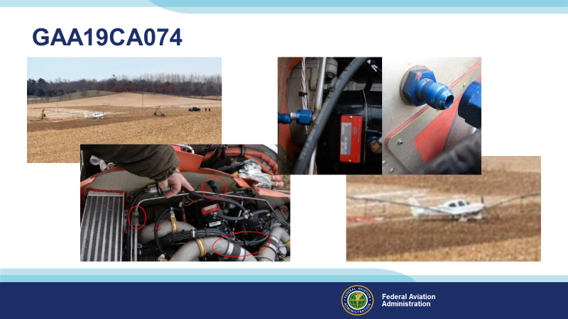 | Slide 9  11/21/2018, Seven hours after maintainers had changed cylinders on a Cirrus SR22, the engine failed while climbing to cruise altitude. The pilot deployed the ballistic parachute. Post-accident examination of the airplane revealed vibration had disconnected the upper deck air lines.  Background:  NTSB# GAA19CA074  The pilot reported that, during a ferry flight, while climbing the airplane to cruise altitude, the engine temperatures increased quickly and that the engine then surged. The pilot added that he “switched” the boost pump, adjusted the mixture lever, and then deployed the ballistic parachute system at 3,500 ft  mean sea level. During the off-airport landing in a field, the airplane impacted an irrigation sprinkler system. The airplane sustained substantial damage to the fuselage.  Post accident examination of the airplane by a Federal Aviation Administration (FAA) inspector revealed that two air lines were disconnected and that there were no torque lines on the lines. According to the FAA inspector, the pilot and a mechanic who had conducted the airplane’s last maintenance reported that the airplane had been flown 7 hours since the last maintenance. The mechanic had replaced three cylinders during the maintenance, which required removal of the air lines. It is likely that, during the maintenance, the mechanic did not properly secure the air reference line, which led to a loss of engine power.  (Next Slide)
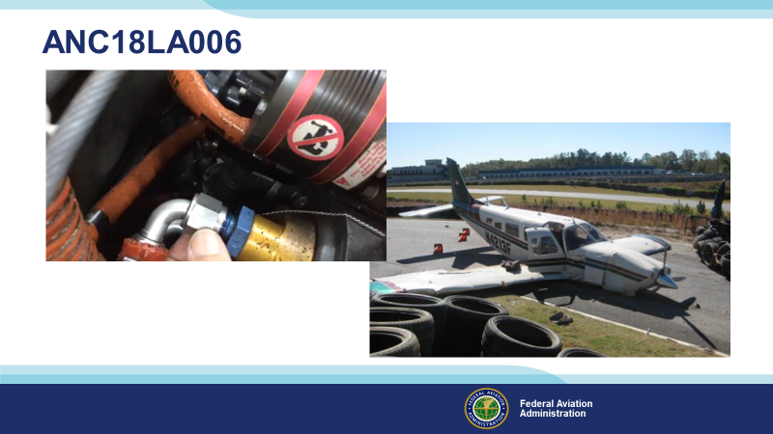 | Slide 10  On 10/30/2017, a Piper PA32R-300 was climbing to cruise altitude when the engine lost power. The pilot selected an area on an asphalt-covered automobile racetrack to make a forced landing. Fortunately, he survived, although he was seriously injured. (Click) The airplane had a remotely mounted oil filter. Investigators found a B-nut on one of the oil filter lines loose with about 2 ½ threads showing. They tightened the B-nut by hand. It rotated about 1 ¾ turns, which resulted in about ½ thread showing. Apparently, the hose had to be removed to change the oil filter during an oil change.  This is a case where a very slight mistake, finger tightening a B-Nut without torquing it later, had a considerable consequence.  Background:  NTSB# ANC18LA006 PA 32R-300  The private pilot was conducting a personal flight and reported that, while the airplane was climbing after takeoff, the engine began to run roughly and lose power. The pilot began a descent for an emergency landing and, during the descent, he sensed a “bad” engine vibration, which was followed by a complete loss of engine power. The pilot selected an area on an asphalt-covered automobile racetrack to make a forced landing, which resulted in substantial damage to the airplane’s wings and fuselage.  A post accident engine examination revealed a crack in the accessory case and a large hole in the crankcase near the No. 6 cylinder pad. A subsequent internal examination revealed damage to the engine’s internal components, including the main bearings and the No. 6 connecting rod, that was consistent with oil exhaustion. The airplane was equipped with a remotely mounted oil filter. A B-nut on one of the oil filter lines was found to be loose with about 2 ½ threads showing. The B-nut was tightened by hand and rotated about 1 ¾ turns, which resulted in about ½ thread showing. The pilot stated that he was not an airframe and powerplant mechanic but that he had replaced the oil line about 1 week before the accident. The accident flight was the first flight after that maintenance.  (Next Slide)
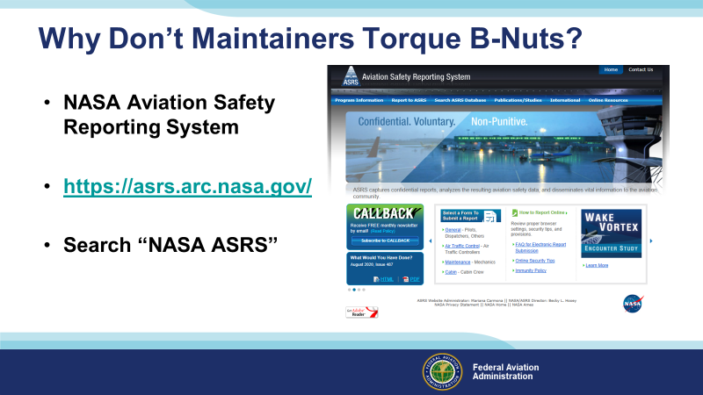 | Slide 11  Why do maintainers let loose B-Nuts escape? There are many reasons. NASA’s Aviation Safety Reporting System has about 50 reports that mention B-Nuts. The great thing about ASRS is that it is a database of reports written by airmen who made mistakes. The airmen endeavor to explain what caused them to make them. We can benefit from these hard-earned lessons. Let’s have a look.  (Next Slide)
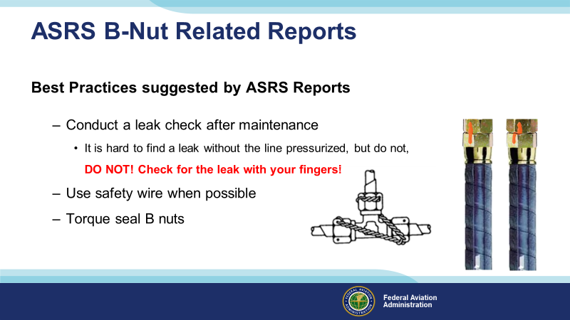 | Slide 12  Leak checks are necessary, but the pressure in lines is often very high. Doctors can remove damaged tissue, but they can’t remove the fluid that incurs into your fingers. It is an injury you will want to avoid.  Distraction is one reason a maintainer may leave a B-Nut loose.  Lock wire or torque seal can provide a ready reference point to return to after a distraction.  (Next Slide)
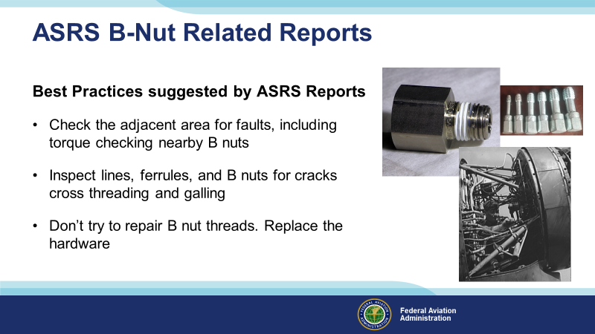 | Slide 13  It is a good idea to check any B-Nut in the area when closing out a project. There are times when a maintainer needs to disconnect adjacent lines rather like a sliding puzzle to allow enough room to swing the wrench to torque the line they are replacing.  Inspect the hardware and don’t try to repair galled cross-threaded or cracked nuts. It is simple. Damaged hardware won’t hold pressure.  Background:  Copyright attribution for the thread galling picture  <a title="Kees08, CC BY-SA 4.0 &lt;https://creativecommons.org/licenses/by-sa/4.0&gt;, via Wikimedia Commons" href="https://commons.wikimedia.org/wiki/File:External_Thread_Galling.png"><img width="512" alt="External Thread Galling" src="https://upload.wikimedia.org/wikipedia/commons/thumb/f/f6/External_Thread_Galling.png/512px-External_Thread_Galling.png"></a>  (Next Slide)
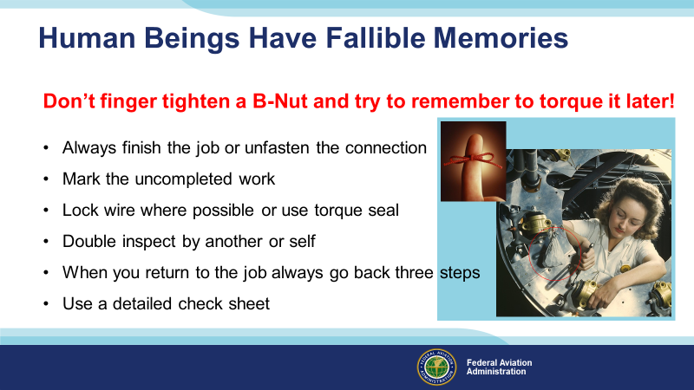 | Slide 14  If you don’t remember any of this presentation, remember this, “Don’t finger tighten a B-Nut and try to remember to torque it later!” This is a problem because it sets maintainers up to fail. The most common cognitive failures in maintenance incidents are failures of memory. Rather than forgetting something in the past, the maintainer forgets to perform an action they intended to accomplish in the future. This is the memory for intentions, also known as prospective memory. What can we do to combat this very natural error trap?  Always finish the job or unfasten the connection  Torquing a “B” nut will prevent an accident. It is the normal condition of the B-Nut…it’s all good. The alternative is leaving the connection unfastened. That also will prevent an accident. The engine would not start or the system will not work if the hose or tube is disconnected.  Mark the uncompleted work.  For instance, hang the loose hardware in a bag attached to the component that is not connected.  Lock wire where possible or use torque seal.  Lock wire or torque seal can provide a ready reference point to return to after a distraction.  Double inspect by another or self.  Inspection can cover a multitude of sins. It is the generic safety net. It is always helpful to ask for someone else’s perspective.  When you return to the job, always go back three steps.  When possible, this is helpful. A word of warning is that if the work card will not allow consecutive work. If the technician needs to skip steps to make the procedure work, then the work card needs to be rewritten, and going back three steps may not help.  Use a detailed check sheet.  A detailed check sheet helps navigate when we forget where we are in the process.  (Next Slide)
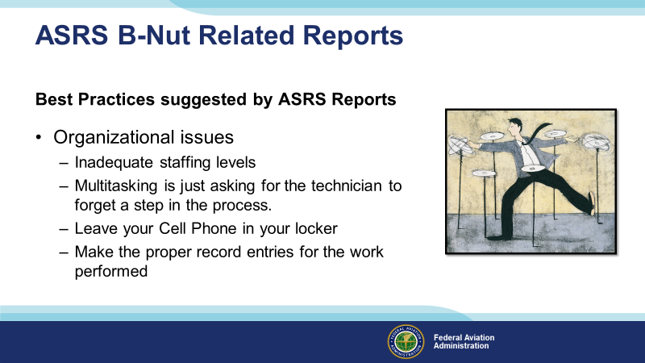 | Slide 15  Inadequate staffing levels and continuously being on call, the pressure to produce and fatigue cause people to make mistakes.  Multitasking may make sense when you are sitting at a desk, but it is just asking for the technician to forget a step in the process on the hangar floor.  Does anyone here have a cell phone? Yep, it is a fact of life. Try to leave your cell phone in your locker.  Make the correct record entries for the work performed. Particularly if you have not completed the job and someone else must close it out. Give them a break, let them know where in the process you stopped work.  (Next Slide)
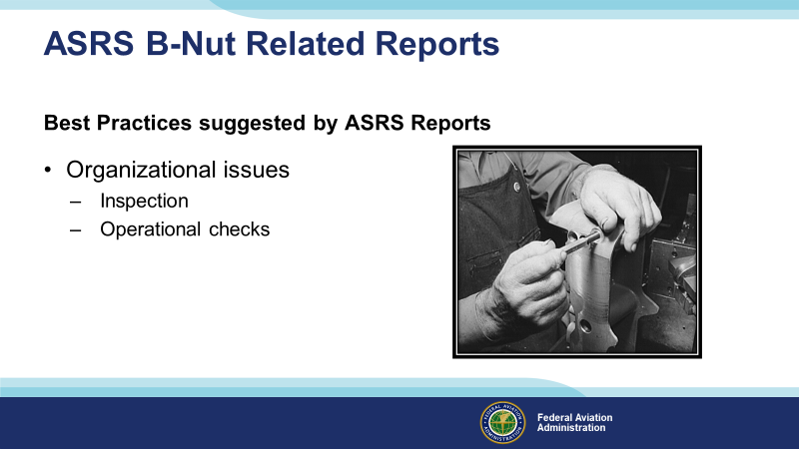 | Slide 16  Inspection  Re-inspect or have someone inspect your work before return to service. Inspection is an excellent safety net. Go over your work or, better yet, have someone else go over it. A second set of eyes can be invaluable in spotting deficiencies.  Operational checks  Perform the operational checks in accordance with the manufacturer’s or air carrier’s approved procedures. Performing operational checks of the fluid carrying systems would reveal loose b-nuts and advert a maintenance related engine failure. Don’t use your fingers!  (Next Slide)
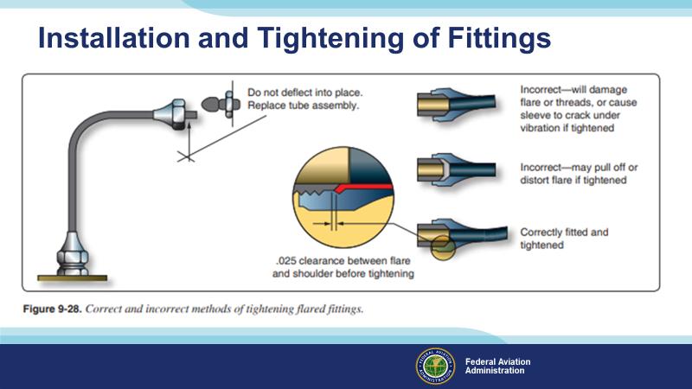 | Slide 17  When reinstalling or when replacing the entire tube assembly, obtain a completely new tube assembly. Make sure the new tube assembly can be installed without pre-stressing the end fitting connections. Too much pre-stress to the end, fitting connections may significantly affect tube life. Use Illustrated Parts List part numbers and follow the appropriate sections of the airframe manufacturer’s maintenance manual. If you have to make the replacement tubing yourself, always ensure that the repair tube material is of the correct material type, size, and wall thickness in accordance with the manufacturer’s instructions. Damaged end fittings may be cut off and replaced, but care should be taken that the repaired assembly fits the installation and that no pre-stress is imparted to the repaired tube due to misalignment or differences in length caused by the repair.  After the defective tube assembly is removed from the aircraft, there are five basic steps to follow:  1. Cut the defective area out of the assembly  2. Deburr the cut ends  3. Form the replacement tube section  4. Install the new tube section and/or fittings  5. Inspect the new tube assembly  (Next Slide)
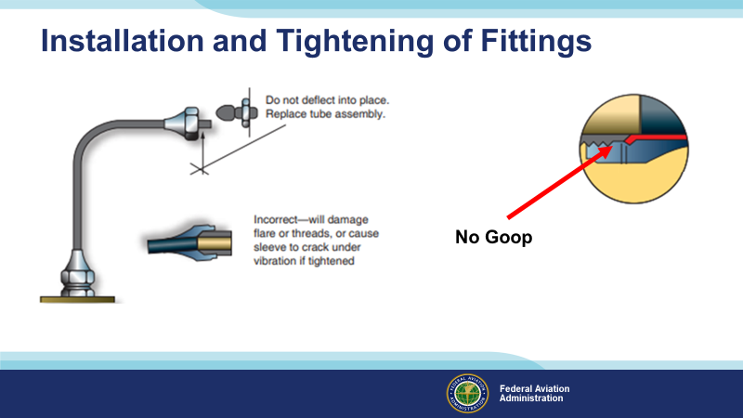 | Slide 18  When connecting hose or tube fittings never apply compound to the faces of the fitting or the flare, as it destroys the metal to metal contact between the fitting and flare, a contact which is necessary to produce the seal. Be sure the that the line assembly is properly aligned before tightening the fittings. Do not pull the installation into place with torque on the nut. Tighten and torque the B-Nut to the proper value as soon as you install it. Never hand tighten the b-nuts without immediately securing the fittings…because it is easy to forget to torque it later.  Alignment. Locate bends accurately so that the tubing is aligned with all support clamps and end fittings and is not drawn, pulled, or otherwise forced into place by them. Never install a straight length of tubing between two rigidly-mounted fittings. Always incorporate at least one bend between such fittings to absorb strain caused by vibration and temperature changes.  (Next Slide)
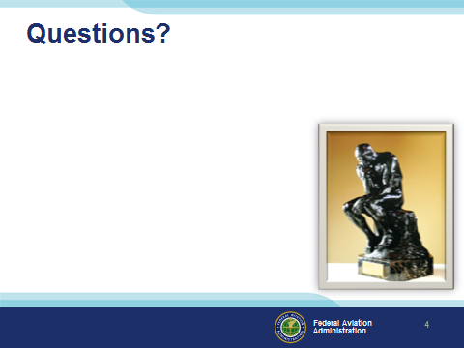 | Slide 19  Presentation Note: You may wish to provide your contact information and main FSDO phone number here. Modify with your information or leave blank.  (Next Slide)
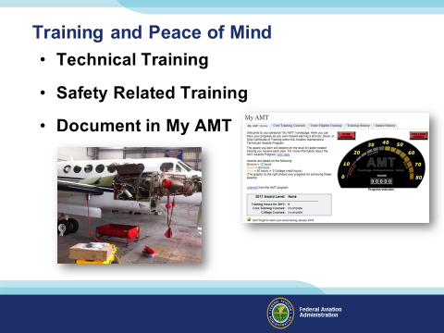 | Slide 20  Presentation Note:  The AMT Awards program encourages AMTs and employers to take advantage of initial and recurrent training by issuing awards based on training received in one calendar year.  The program has several levels, or phases, of recognition for both you and your employer. You can obtain an FAA Certificate of Training upon successful completion of the program requirements. Employers can obtain a Gold or Diamond Award of Excellence yearly depending on the percentage of their employees receiving awards.  Training earned toward an AMT Award falls into one of two categories; Mandatory Core Training and Eligible Training.  Mandatory Core Training is one or more online training courses, depending on FAA evaluation of training needs. The Core Training course(s) can be located and completed in the Aviation Learning Center at FAASafety.gov.  Eligible Training is the hourly training that can be credited toward an individual AMT Certificate of Training. This training must be aviation maintenance career related training.  Be sure to document your achievement in the AMT Awards Program. It’s a great way to stay on top of your game and keep stay proficient.  (Next Slide)
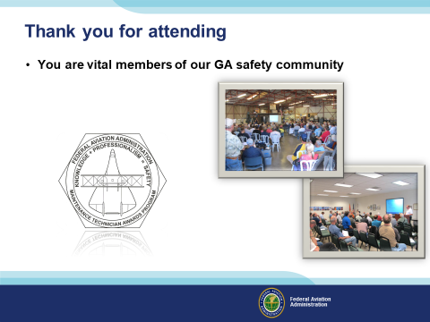 | Slide 21  Your presence here shows that you are vital members of our General Aviation Safety Community. The high standards you keep and the examples you set are a great credit to you and to GA.  Thank you for attending.  (The End)

